**EKS – EFS SETUP**

root@DESKTOP-THNIIG3:/mnt/c/Users/Admin/Desktop/TERRAFORM/K8S# **cd EKS/**

root@DESKTOP-THNIIG3:/mnt/c/Users/Admin/Desktop/TERRAFORM/K8S/EKS# **ll**

total 45316

drwxrwxrwx 1 amaan amaan 512 Feb 20 14:57 ./

drwxrwxrwx 1 amaan amaan 512 Feb 27 13:42 ../

-rwxrwxrwx 1 amaan amaan 504 Feb 20 14:59 **eks-cube-cluster.yaml**\*

-rwxrwxrwx 1 amaan amaan 46403584 Feb 20 14:56 kubectl*

root@DESKTOP-THNIIG3:/mnt/c/Users/Admin/Desktop/TERRAFORM/K8S/EKS# **eksctl create cluster -f eks-cube-cluster.yaml**

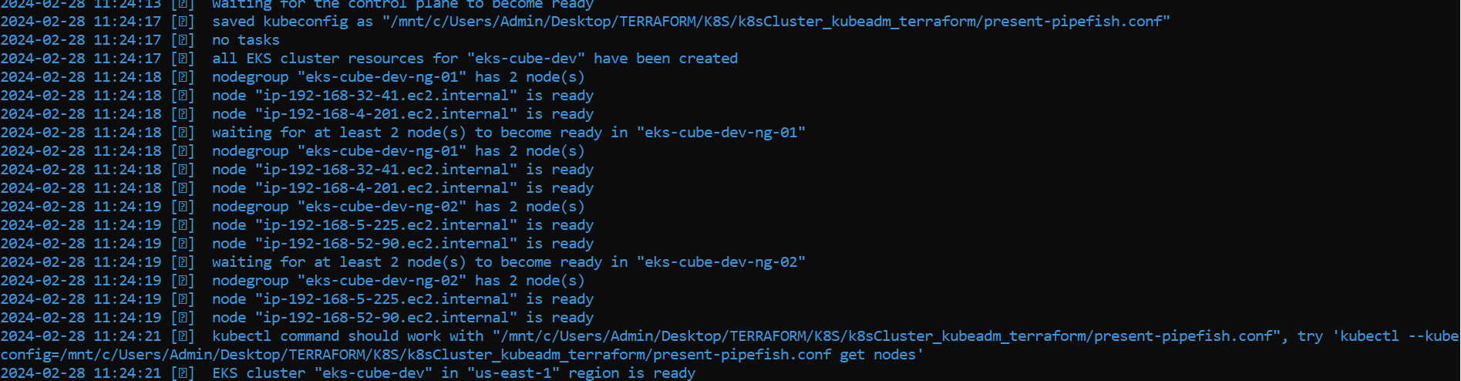

root@DESKTOP-THNIIG3:/mnt/c/Users/Admin/Desktop/TERRAFORM/K8S/EKS# **aws eks --region us-east-1 update-kubeconfig --name eks-cube-dev**

Added new context arn:aws:eks:us-east-1:205016943172:cluster/eks-cube-dev to /mnt/c/Users/Admin/Desktop/TERRAFORM/K8S/k8sCluster_kubeadm_terraform/present-pipefish.conf

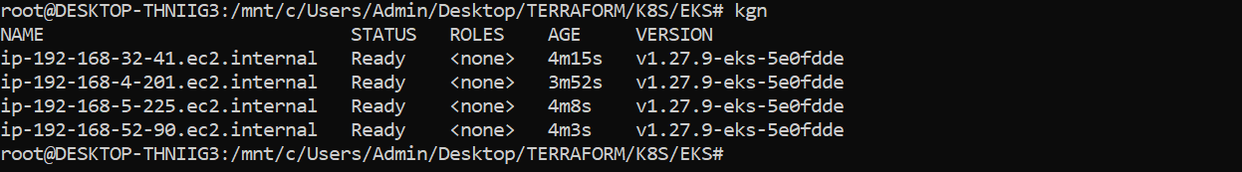

* **EFS CREATION**

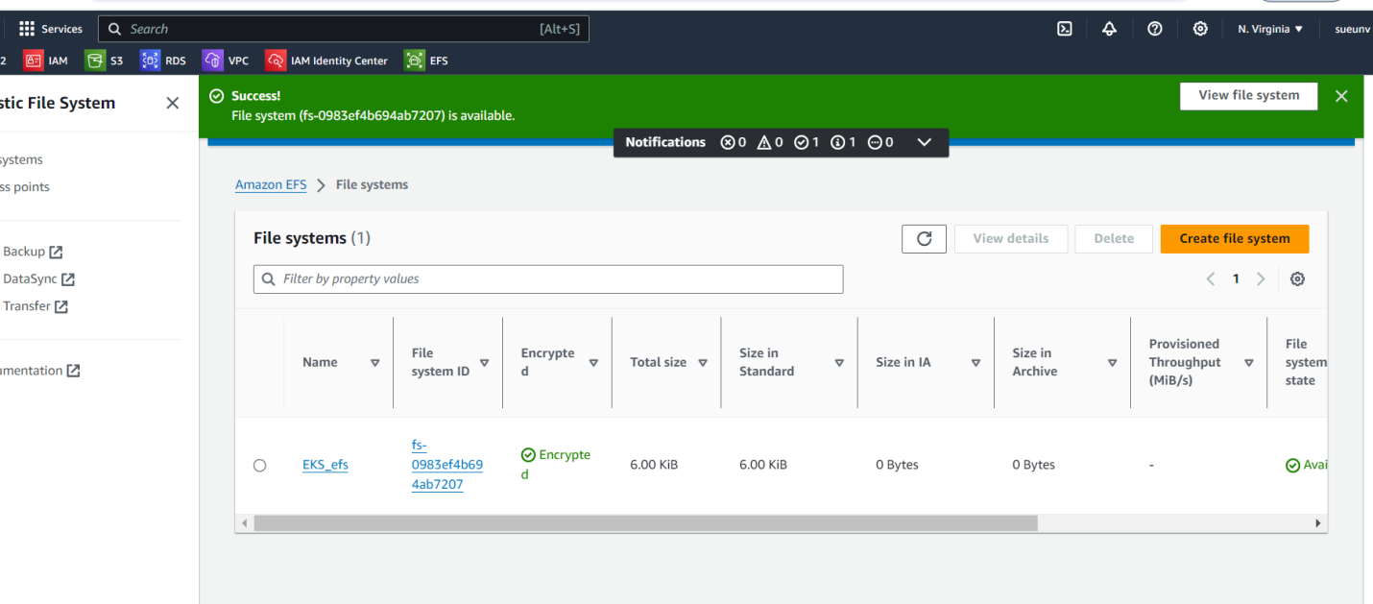

* **VPC ID**

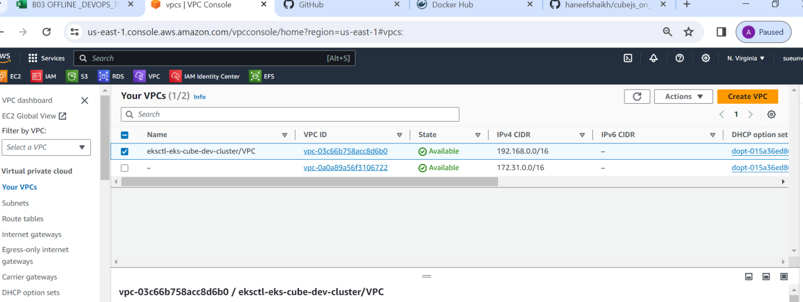

* **NETWORK TYPES**

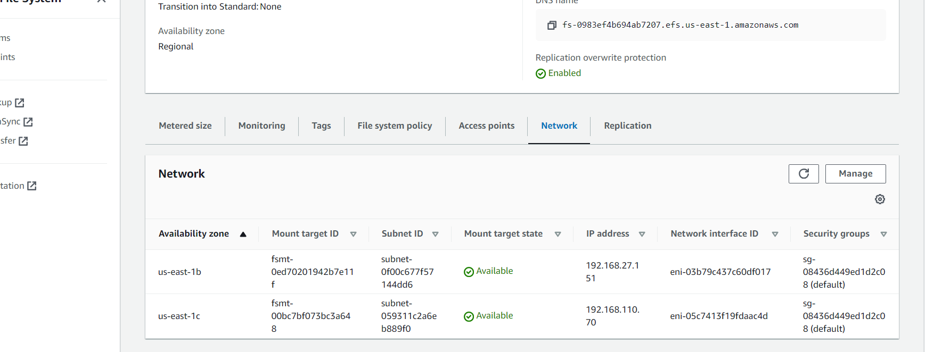

* **SECURITY GROUP IS READY**

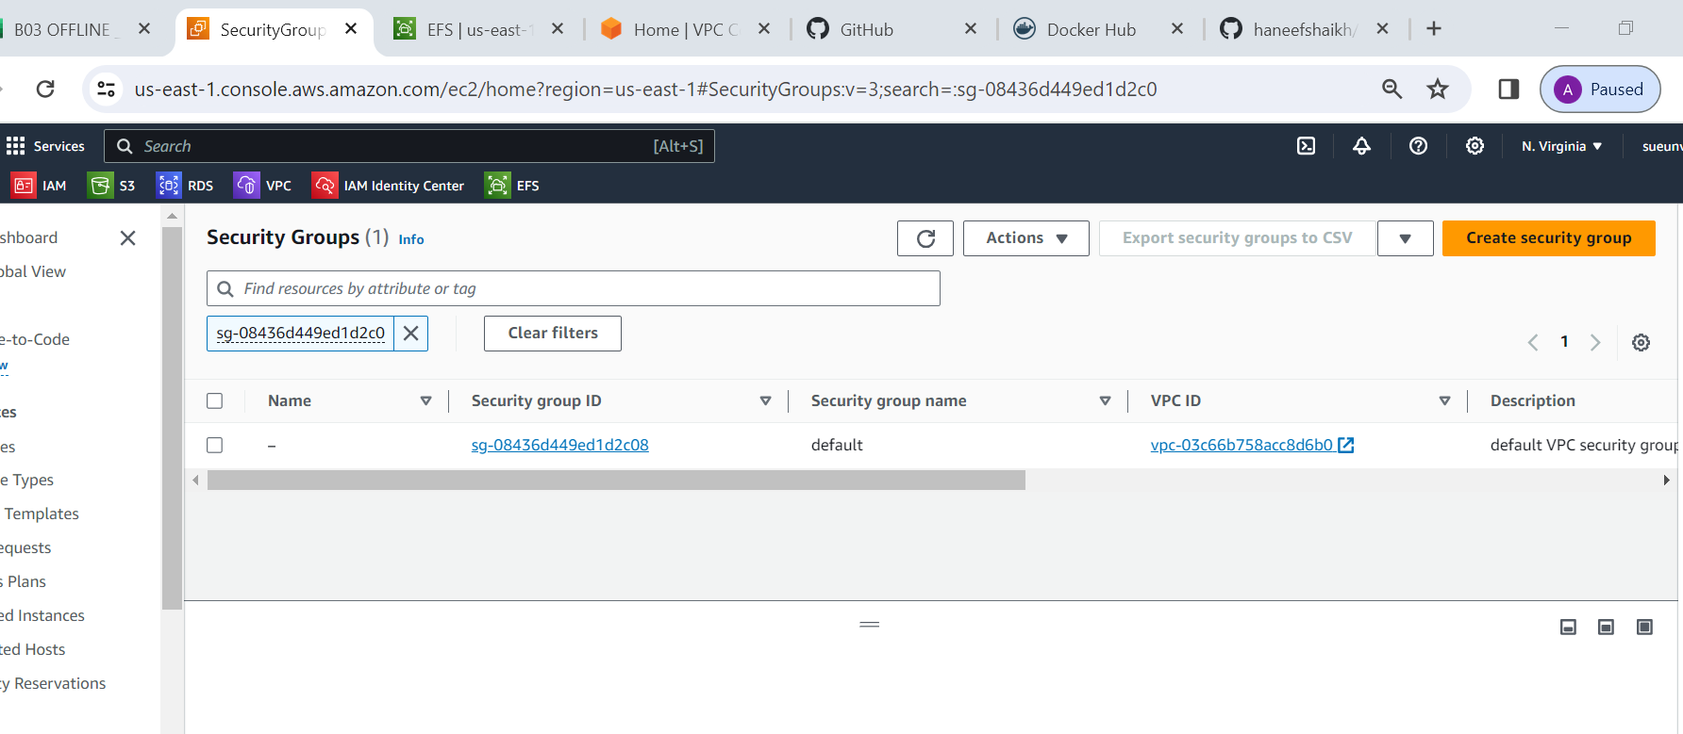

* **ADD INBOND RULE**

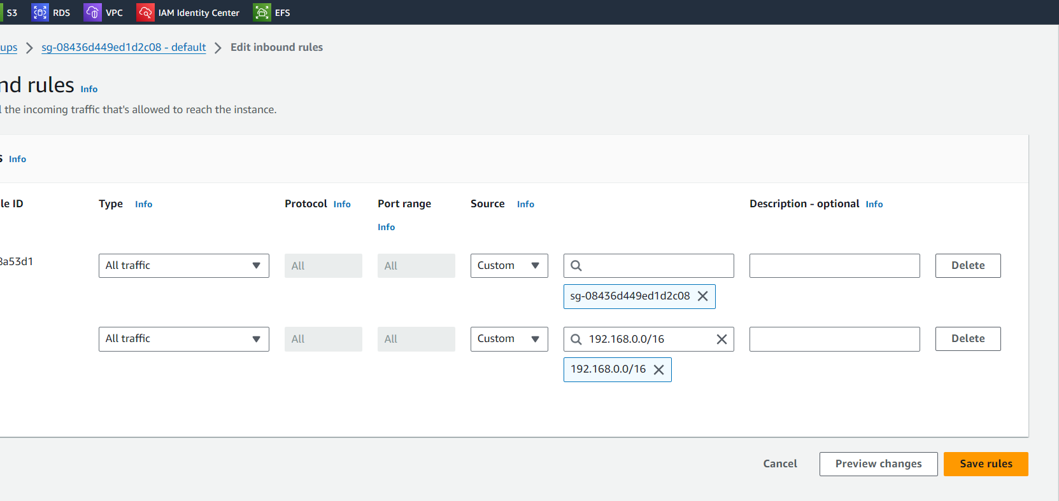

* **SG RULES SUCCESSFULLY**

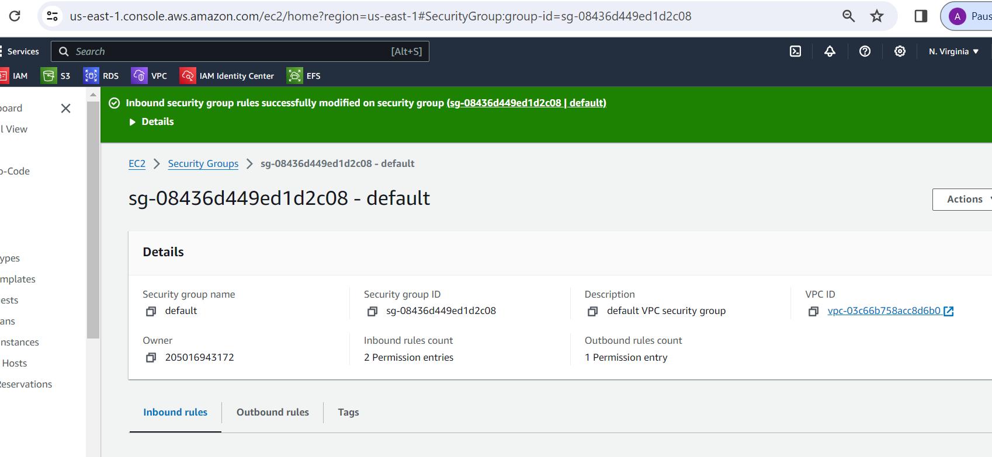

root@DESKTOP-THNIIG3:/mnt/c/Users/Admin/Desktop/TERRAFORM/K8S/EKS# **mkdir eks_pvc**

root@DESKTOP-THNIIG3:/mnt/c/Users/Admin/Desktop/TERRAFORM/K8S/EKS# **ll**

total 45316

drwxrwxrwx 1 amaan amaan 512 Feb 28 12:04 ./

drwxrwxrwx 1 amaan amaan 512 Feb 27 13:42 ../

-rwxrwxrwx 1 amaan amaan 504 Feb 20 14:59 eks-cube-cluster.yaml*

drwxrwxrwx 1 amaan amaan 512 Feb 28 12:04 eks_pvc/

-rwxrwxrwx 1 amaan amaan 46403584 Feb 20 14:56 kubectl*

root@DESKTOP-THNIIG3:/mnt/c/Users/Admin/Desktop/TERRAFORM/K8S/EKS# **cd eks_pvc/**

root@DESKTOP-THNIIG3:/mnt/c/Users/Admin/Desktop/TERRAFORM/K8S/EKS/eks_pvc# **ll**

total 0

drwxrwxrwx 1 amaan amaan 512 Feb 28 12:04 ./

drwxrwxrwx 1 amaan amaan 512 Feb 28 12:04 ../

root@DESKTOP-THNIIG3:/mnt/c/Users/Admin/Desktop/TERRAFORM/K8S/EKS/eks_pvc# **touch pv.yaml**

root@DESKTOP-THNIIG3:/mnt/c/Users/Admin/Desktop/TERRAFORM/K8S/EKS/eks_pvc# **touch pvc.yaml**

root@DESKTOP-THNIIG3:/mnt/c/Users/Admin/Desktop/TERRAFORM/K8S/EKS/eks_pvc# **touch pod.yaml**

* **ADD (fs-id) to PV.YAML FILE**

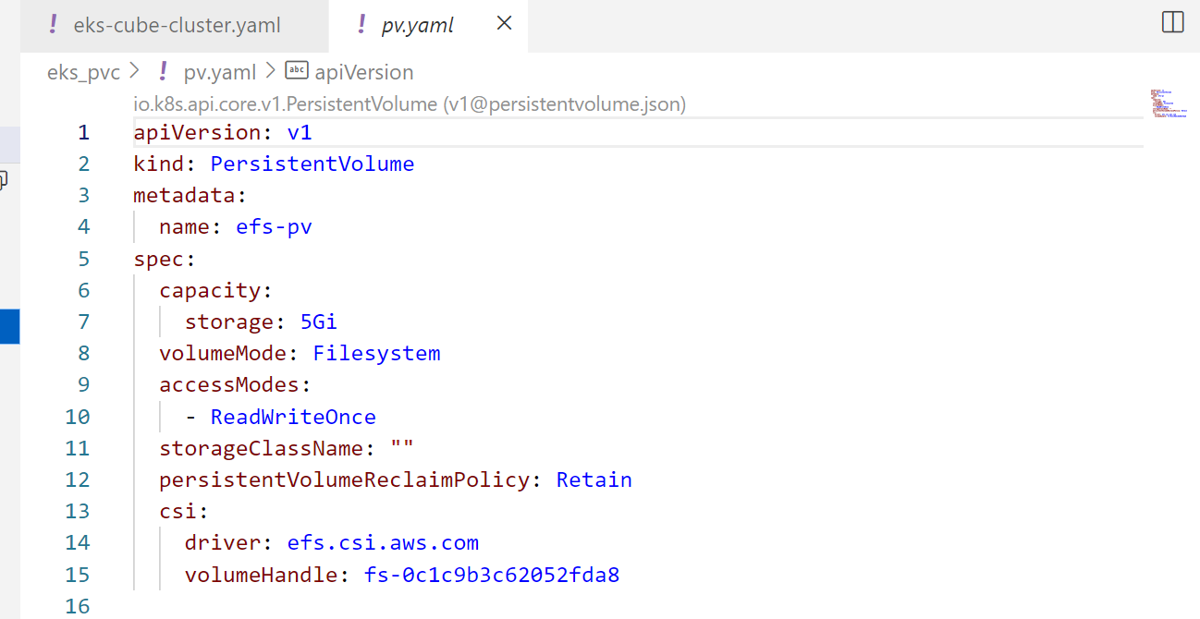

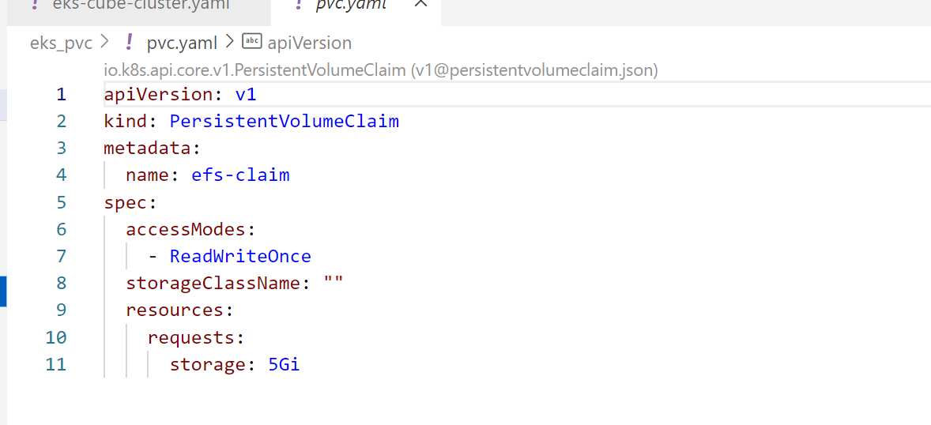

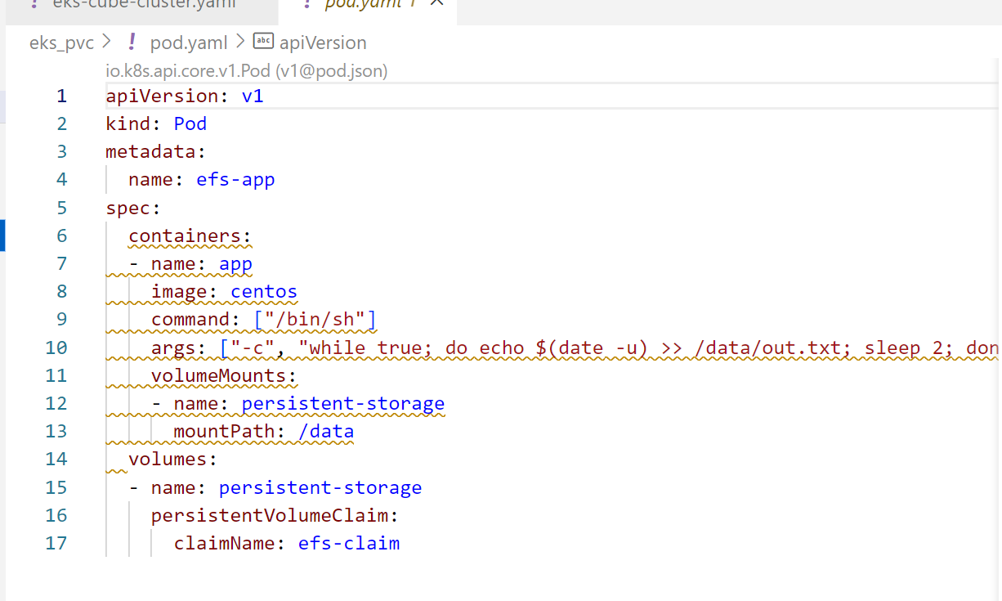

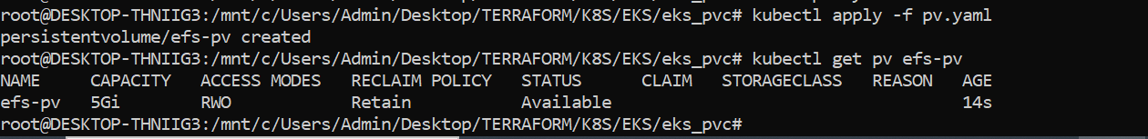

* **Now let’s check the status of the PV and PVC:**

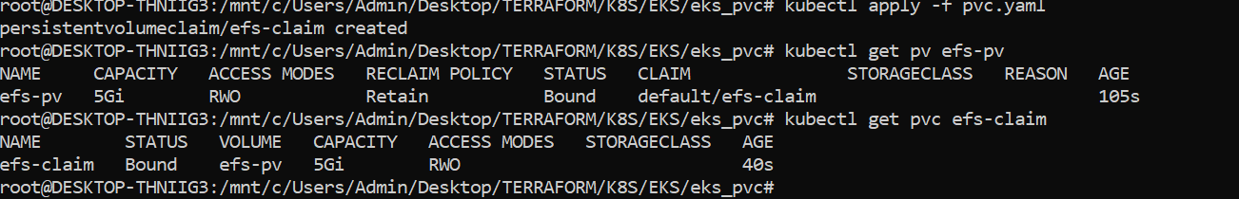

* **Check again whether an IAM OIDC provider with your cluster's ID is created in your account**
* **Create an IAM policy**
* **Download the IAM policy document**

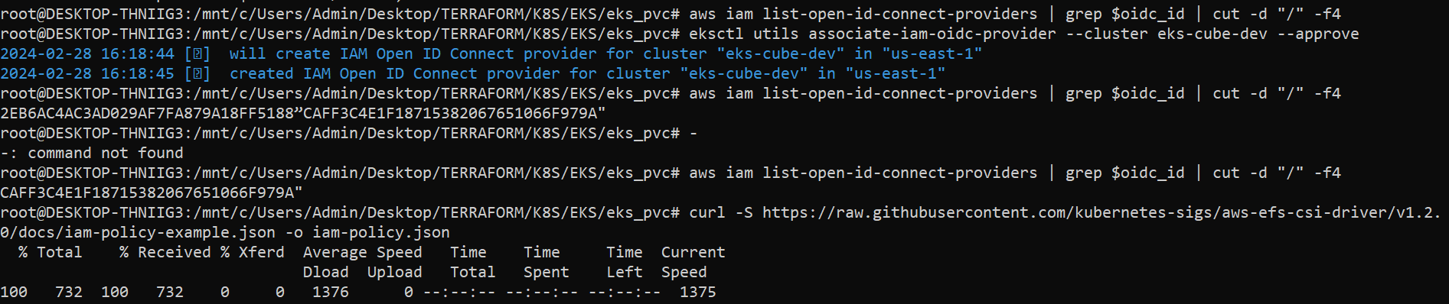

* **Create a Kubernetes service account**



* **Create a Kubernetes service account**
* **To verify that the new service role is created, run one of the following commands:**

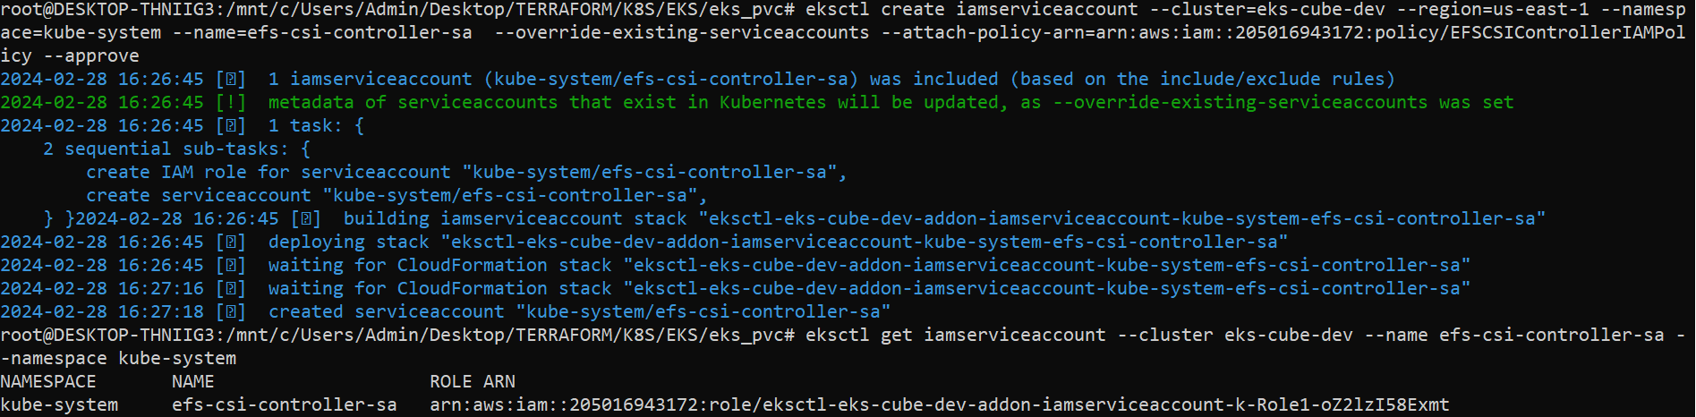

* **Now install AWS EFS Storage Controller driver.**
* **To verify that aws-efs-csi-driver has started, run:**

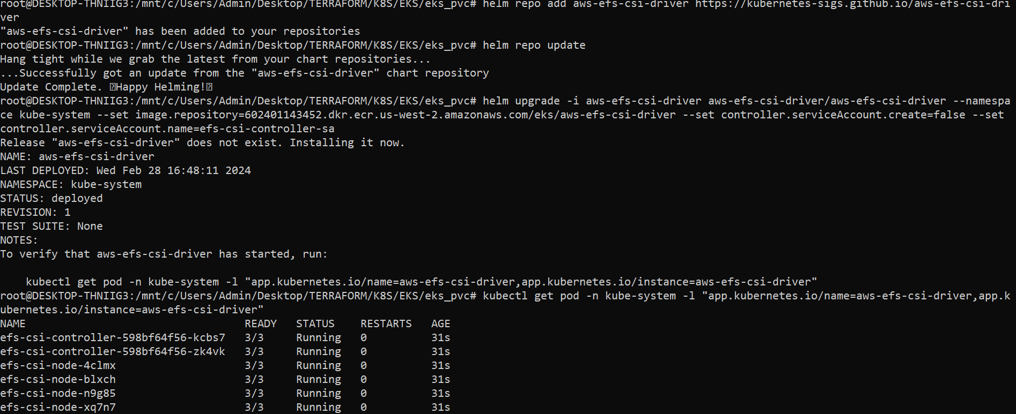

* **Efs pod is Running**

